
SRM Institute of Science and Technology
College of Engineering and Technology
Mode of Exam
OFFLINE
School of Computing
DEPARTMENT OF COMPUTATIONAL INTELLIGENCE
SRM Nagar, Kattankulathur – 603203, Chengalpattu District, Tamilnadu
Academic Year: 2024-2025 (ODD) SET - A
Test: CLAT-1 Date: 27/06/2024
Course Code & Title: 18AIE424T- ARTIFICIAL INTELLIGENCE AND INTERNET OF THINGS
Duration: 1 Hour 40 minutes
Year & Sem: IV & VII Max. Marks: 50

Course Articulation Matrix:

S.No. | Course Outcome | PO1 | PO2 | PO3 | PO4 | PO5 | PO6 | PO7 | PO8 | PO9 | PO10 | PO11 | PO12
1 | CO1 | - | - | - | - | - | - | - | - | - | - | - | -
2 | CO2 | H | - | - | H | H | - | - | - | M | L | - | H
3 | CO3 | H | - | - | H | H | - | - | - | M | L | - | H
4 | CO4 | - | - | - | - | - | - | - | - | - | - | - | -
5 | CO5 | - | - | - | - | - | - | - | - | - | - | - | -

Part - A
( 10 x 1 = 10 Marks)
Instructions: Answer all
Q. No | Question | Marks | BL | CO | PO | PI Code
1 | The entropy of a perfectly balanced binary classification dataset is:  a. 0  b. 0.5  c. 1  d. -1 | 1 | 1 | 2 | 1,4 | 1.4.1
2 | Recurrent Neural Networks (RNNs) are particularly well-suited for:  a. Image classification tasks  b. Handling temporal sequences of data  c. Reducing dimensionality  d. Performing feature selection | 1 | 1 | 2 | 1 | 1.4.1
3 | The Gini impurity index in a decision tree measures:  a. The probability of misclassifying an element  b. The entropy of the dataset  c. The gain ratio  d. The information gain. | 1 | 1 | 2 | 1 | 1.3.1
4 | The sigmoid function in logistic regression outputs a value between:  a. -1 and 1  b. 0 and 1  c. -∞ and ∞  d. 0 and ∞. | 1 | 1 | 2 | 1 | 1.3.1
5 | In a Naïve Bayes classifier, the posterior probability is calculated using:  a. Bayes' theorem  b. Markov Chains  c. Linear algebra  d. Gradient descent | 1 | 2 | 2 | 1 | 1.3.1
6 | Which layer type is typically used to extract local features in a CNN?  - Convolutional layer  - Pooling layer  - Fully connected layer  - Activation layer | 1 | 1 | 3 | 1 | 1.3.1
7 | What is the purpose of the stride parameter in a convolutional layer?  - To determine the size of the receptive field  - To control the step size of the convolution operation  - To adjust the learning rate during training  - To reduce the dimension | 1 | 1 | 3 | 1 | 1.3.1
8 | Which layer type is responsible for applying non-linear transformations to the feature maps in a CNN?  - Convolutional layer  - Pooling layer  - Fully connected layer  - Activation layer | 1 | 1 | 3 | 1 | 1.3.1
9 | What is true regarding backpropagation rule?  - it is a feedback neural network  - actual output is determined by computing the outputs of units for each hidden layer  - hidden layers output is not all important, they are only meant for supporting input and output layers  - Dimensionality reduction | 1 | 2 | 3 | 1,4 | 1.3.1
10 | What is the purpose of the fully connected layers in a CNN?  - To capture global patterns and make predictions  - To reduce the spatial dimensions of the input data  - To apply non-linear transformations to the feature maps  - To initialize the weights and biases of the network | 1 | 1 | 3 | 1 | 1.3.1
Part – B
( 4 x 5 = 20 Marks)
Instructions: Answer any 4
11 | Can you describe the architecture of an LSTM cell and how it stores and retrieves information over long sequences? | 5 | 1 | 3 | 1 | 2.1.1
12 | How does Naive Bayes compare to other classification algorithms like decision trees, support vector machines, or random forests? | 5 | 2 | 2 | 1,5 | 2.1.1
13 | How do RNNs handle sequential data, and what are their advantages in tasks like time series prediction and natural language processing? | 5 | 2 | 3 | 1 | 2.1.1
14 | How are partial derivatives and gradients used to update the weights and biases of a neural network during backpropagation? | 5 | 3 | 3 | 1 | 2.1.1
15 | What are the techniques adopted to resolve uneven data and overfitting? | 5 | 1 | 2 | 1 | 2.1.1
PART – C
(2x 10 =20 Marks)
Instructions: Answer any 2
16 | a) Explain the importance of hyperparameter tuning in SVM. Provide an example where optimizing hyperparameters like the C parameter or kernel parameters significantly improves model performance.  OR  b) (i)Can you explain the concept of diversity in ensemble learning and why it's important for improving model performance? [5 marks]  (ii) Explain the concept of the slope (coefficients) and intercept in a linear regression equation. How are they interpreted in the context of the data? [5 marks] | 10 | 2 | 2 | 1,5 | 2.3.1
17 | What is the architecture of a typical CNN, including convolutional layers, pooling layers, fully connected layers, and output layers? Can you explain the purpose of each layer type?  OR  (i) Compare and contrast the use cases and strengths of CNNs and RNNs. In what types of problems would you choose one over the other? [5 marks]  (ii)What are the key differences between LSTM and GRU architectures, and when might you prefer one over the other for sequential data modeling? [5 marks] | 10 | 3 | 3 | 1,4 | 2.3.1

Course Outcome (CO) and Bloom’s level (BL) Coverage in Questions

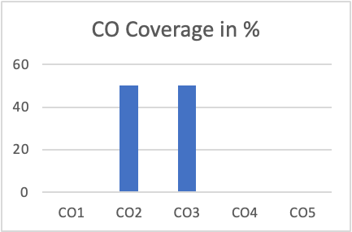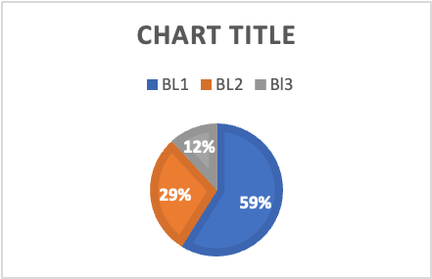

Approved by the Audit Professor/Course Coordinator

